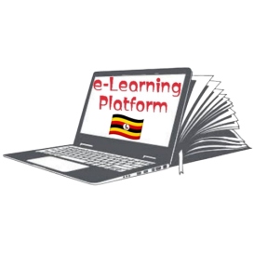**FRESH TEACHER'S E-LIBRARY**

**BEGINNING OF TERM III EXAMINATION 2023**

**MIDDLE CLASS: (4 – 5 YEARS)**

**LEARNING AREA 3: HEALTH HABITS**

**My name is: ……………………………………………………………….**

**My School is: …………………………………….………………………..**

**I am in: ………………………………..…………………………….…………………..**

1. **Read and match.**

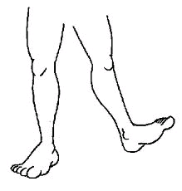ear

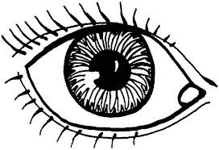

nose

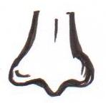

mouth

eye

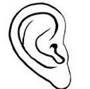

leg

1. **Name these pictures.**

**[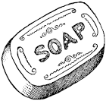](http://www.google.co.ug/imgres?imgurl=http://etc.usf.edu/clipart/19100/19127/soap_19127_lg.gif&imgrefurl=http://etc.usf.edu/clipart/19100/19127/soap_19127.htm&usg=__X2zEXi_NshsM831SBoX1qtRosa4=&h=663&w=700&sz=48&hl=en&start=20&zoom=1&tbnid=kjnNfH9gkO-xyM:&tbnh=133&tbnw=140&ei=HJa2TbyWB8ftOaXSwP4O&prev=/search?q=soap&hl=en&sa=N&gbv=2&tbm=isch&itbs=1)**

__________________

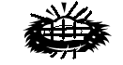

__________________

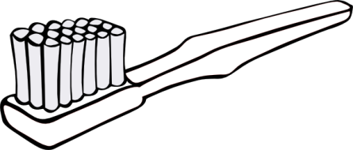 ___________________

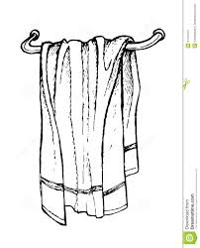

___________________

(towel, sponge, toothbrush, soap)

1. **Match the pictures to their words.**

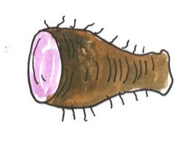

pumpkin

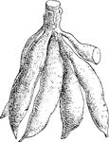

irish potato

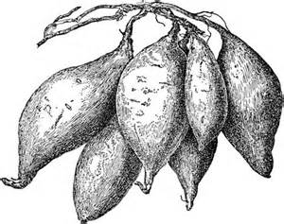

yam

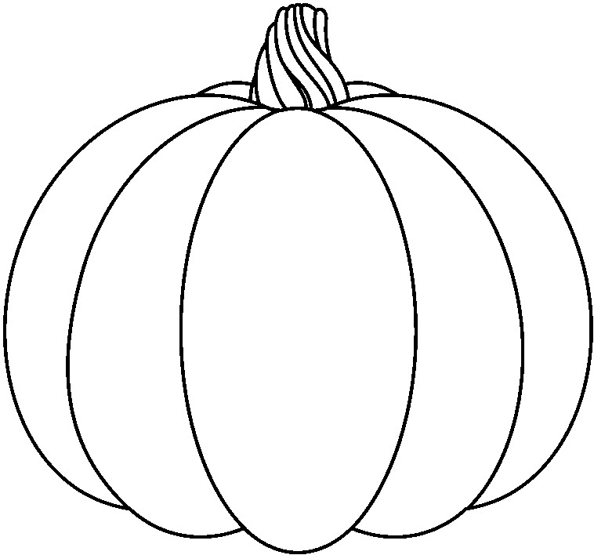

cassava

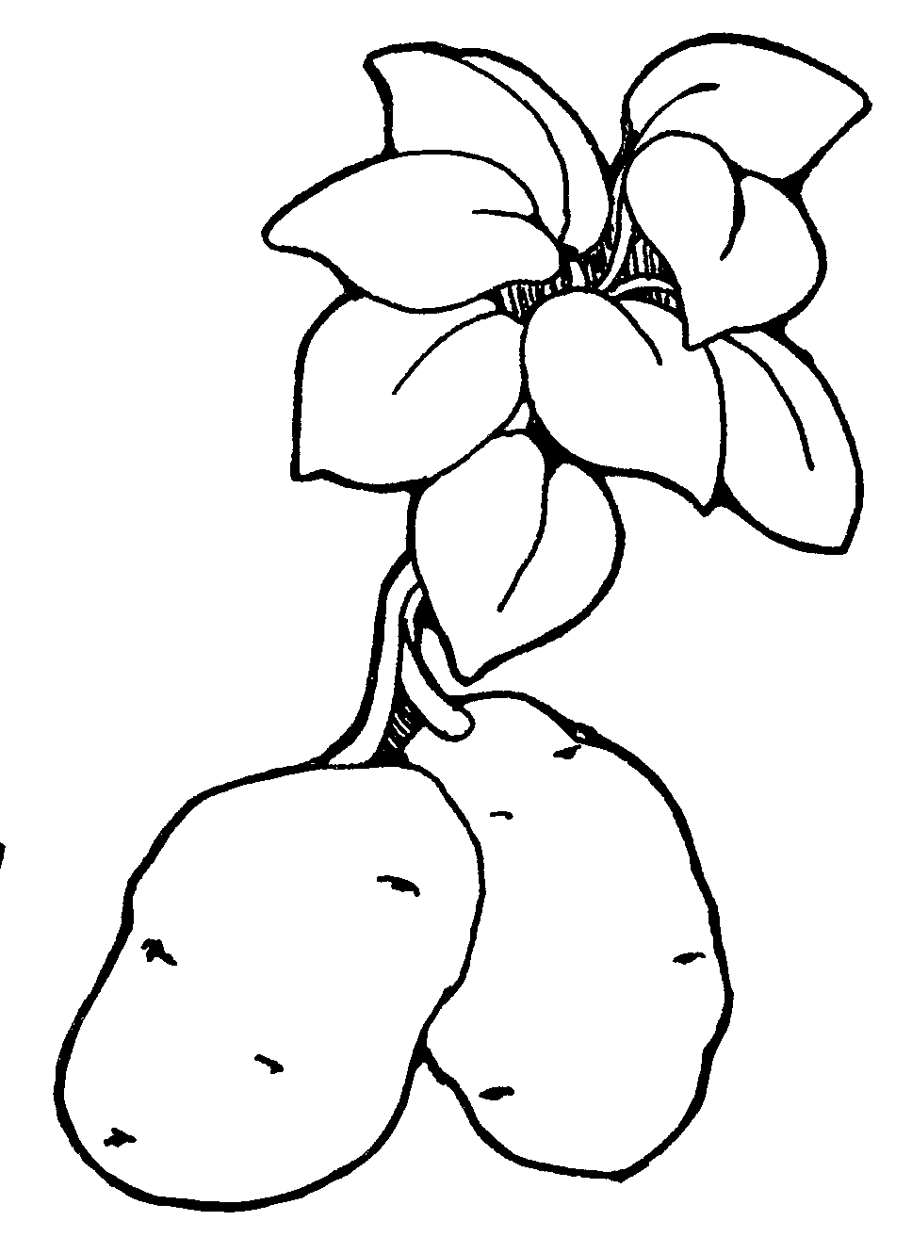

sweet potato

1. **Fill in the missing letter.**

n ___il

st ___ne

fi ____e

p ____ n

n ee dle

1. 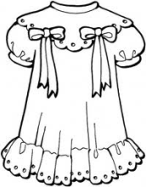**Name and colour things we wear.**

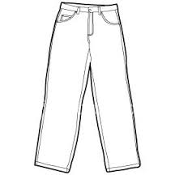

_______________ ___________

(trouser, dress)

**End**